Project Development Phase
Workflow Performance Test

Date | 8 October 2026
Team ID | 9100MindMesh
Project Name | Streamlining IT Procurement: Automating Standard Laptop Orders with Flow Designer
Maximum Marks

Workflow Performance Testing:
Project team shall fill the following information in the workflow performance testing template.
S.No. | Parameter | Screenshot / Values
1. | Service Catalog Request | Standard laptop request is submitted through the Service Catalog. The request captures the laptop requirement and starts the procurement workflow.  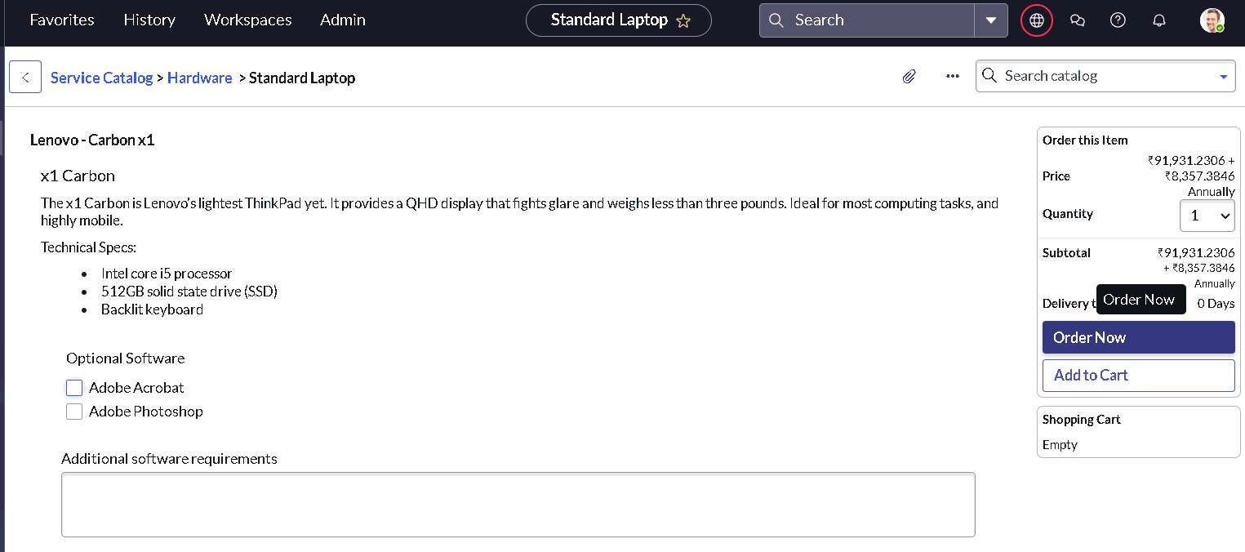
2. | Flow Trigger Configuration | The flow is configured with a Service Catalog trigger so that the workflow starts when the relevant standard laptop request is created/submitted.  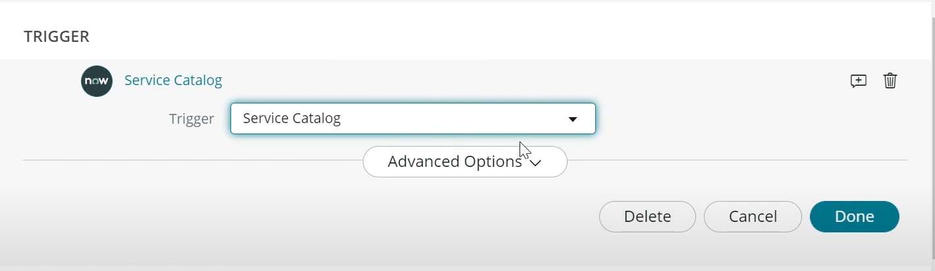
3. | Catalog Task Creation | After the required trigger/approval condition, the flow uses the Create Catalog Task action to generate the configuration task.  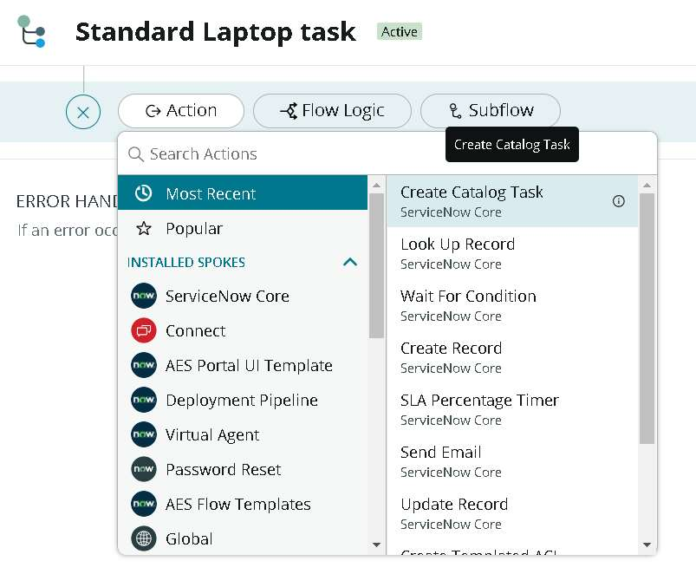
4. | Approval & Hardware Assignment | The request is routed through approval and the created configuration task is assigned to the appropriate Hardware team.  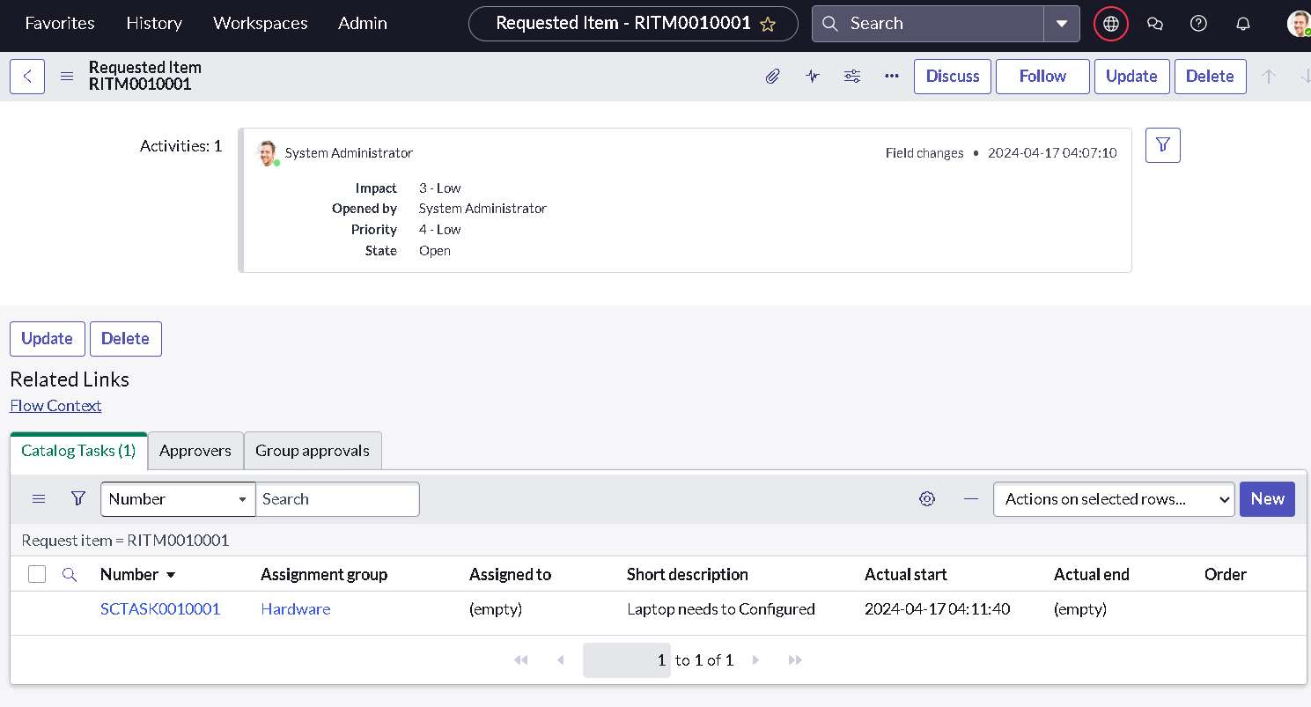
5. | Workflow Testing | The service catalog request and flow are tested to verify that the trigger runs correctly and the workflow produces the expected task.  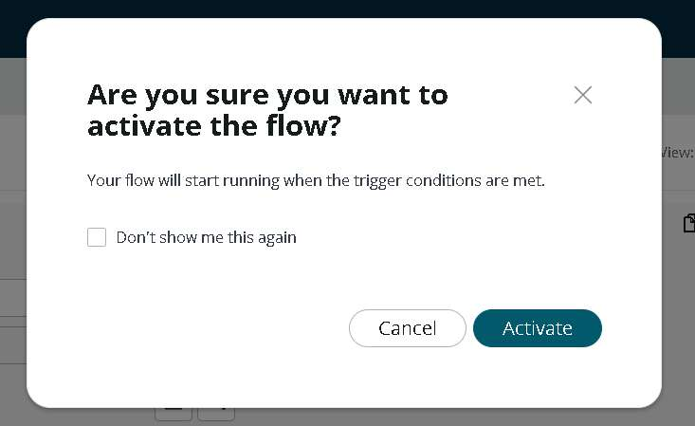
6. | Workflow Output | The completed workflow results in a standard laptop configuration task and supports prompt laptop preparation after approval.  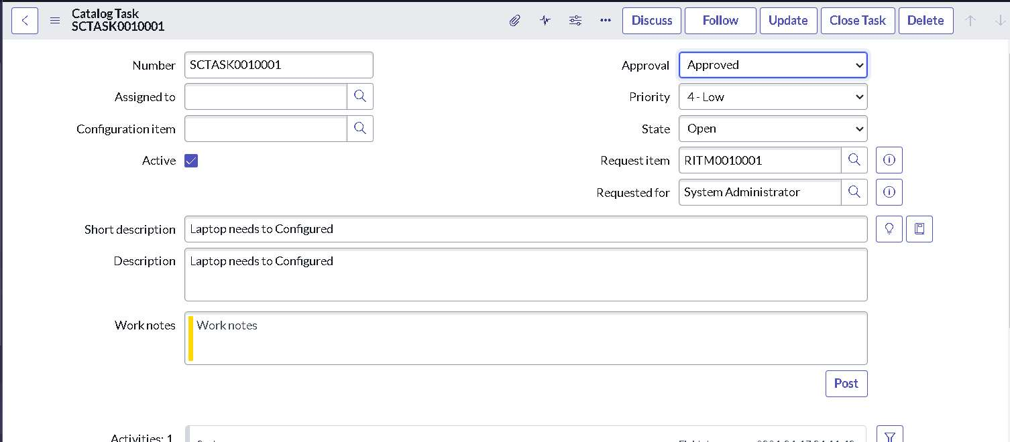

Workflow Summary
• User submits a Standard Laptop Request through the Service Catalog.
• The Service Catalog trigger starts the Flow Designer workflow.
• The flow creates a Catalog Task for laptop configuration.
• Approval and Hardware team assignment are handled within the workflow.
• Testing confirms that the workflow produces the expected configuration task.
Conclusion
The automated ServiceNow Flow Designer workflow reduces manual intervention in standard laptop procurement. By creating and assigning the configuration task after the required approval, the process helps reduce user waiting time, avoid missed or delayed tasks, and improve procurement efficiency.

